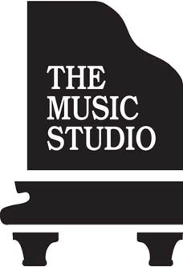

Piano Faculty Opening

TEACHER OF PIANO: Private, well-established school of music located in Albany, New York, has two faculty openings for an exceptional teacher with a degree in piano or piano pedagogy. During our near 50 years as a school, we have won recognition and numerous awards for our innovative, comprehensive, custom-designed program. Many of our students have won regional piano competitions, and performed with the Albany Symphony Orchestra, local jazz musicians, and contemporary composers.

Our curriculum is unique and rigorous; children begin at our school-year program as early as age 4 and can continue with us, first in group classes, then in supplemented private instruction, through high school. Although our standards are high, so is our empathy and engagement. Ours is a warm and welcoming musical community that accepts and supports each student where they are, yet always challenges them to move to the next level. They emerge deeply educated in music theory, highly skilled at the piano, and enriched by a lifelong connection to music and a facility for music-making.

Responsibilities include:

o Teaching well-structured, high-energy music fundamentals classes for children
ages 3–8, with emphasis on singing, ear training, rhythm, movement, reading, keyboard, recorder, and Orff.

o Teaching piano lessons, both private and class, for students and adults of various skill levels.

o Preparing students to perform at their best in periodic recitals, evaluations, and public performances, and helping the Studio administer those events.

This is a full-time salaried position with periodic increases. We offer health and disability insurance, paid vacation, reimbursement for employment-related continued education, and many other benefits. Schedule consists of afternoons, evenings, and Saturdays. This is a 10-month contract; summer hours are available for additional pay.

Our preferred candidates will have a degree in piano or piano pedagogy and experience teaching a range of ages. They will be organized, energetic, and flexible. A positive, can-do attitude is essential.

Full-time position begins immediately with comprehensive training in The Music Studio’s unique curriculum.

Please send resume, cover letter, and three professional references to admin@themusicstudio.com. Call (518) 459-7799 with questions.

1237 Central Avenue, Albany, New York 12205 (518) 459-7799 www.TheMusicStudio.com

