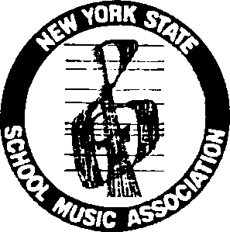
NYSSMA Curriculum Committee
Session Proposal Form
for
NYSSMA’s 90th Winter Conference
December 3– 6, 2026
Submission Deadline — January 14, 2026
NYSSMA members are invited to submit educational session proposals for the Winter Conference to be held in Rochester, NY; December 3 – 6, 2026. Proposals will be evaluated based on the following criteria:
- topic must be associated with music curriculum
- innovativeness
- importance and timeliness of topic
- practical applicability
- program balance
Proposed sessions must not include endorsements for any specific commercial product or service. If your session is accepted, you will be notified by NYSSMA.

PROCEDURE: Complete an application form for each proposed session. Scan and e-mail the completed form, along with the required documents listed below, to:
Fred Weingarten at: curriculum@nyssma.org, by January 14th.
REQUIRED DOCUMENTS TO BE E-MAILED AS ATTACHMENTS:
- Completed Session Proposal form
- Session Title and Abstract (50 words or less)
- Name and contact information of all clinicians
- Outline of session to be presented (in Microsoft Word)
- Résumé for each clinician and/or panelist, including background, qualifications, and recent session presentation experience (in Microsoft Word)
- Describe your teaching background, being sure to include workshops you’ve presented. Copies of past session handouts are appreciated.

Person submitting this form: Home Phone: School Affiliation: Position: Address: Work Phone: City / State: Cell Phone: Zip E-Mail:
Which Learning Standard(s) will this session address?
Will this session require a demo group? If yes, approximate size of group Special Equipment Needs / Requests:
NOTE: Clinicians must be paid members of NAfME/NYSSMA

