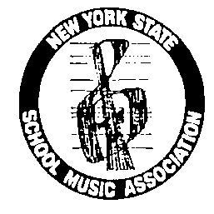
NYSSMA A State Unit of NAfME
_______________________________________________________________

The 49th Annual Joseph R. Sugar NYSSMA Day in Albany
Monday, March 7, 2022

Dear NYSSMA Colleagues,
As your Government Relations Chairman, I am as disappointed as you that Covid has once again forced us into a Virtual Day in Albany. Hopefully by now you have made your appointments with your legislators, if not, please contact them as soon as possible to do so.

As we did in 2021, we will be using Zoom accounts to meet with our legislators, using the following protocol:
- You are encouraged to use your school Zoom account in the event you have access to an account. NYSSMA has a limited number of available accounts.
- For those of you who asked and used a NYSSMA Zoom account last year please use the same account. You may have to reset the password.
- For those of you who need a new NYSSMA Zoom account, please reach out to me at grc@nyssma.org and I will then coordinate with the NYSSMA Office/Dr. Gaines to set up a new 2022 account for you to use.
The key to success of our Day in Albany is relations. The opportunity to create relationships with your legislators is probably the most important part of our Day. When an important group like ours makes the effort to come to Albany in person to talk about music education in a politically savvy fashion, our legislators definitely take notice! Keep in mind that the ability to contact your legislator, albeit virtually, have them know who you are and welcome your contacting them is a vital part of how we accomplish our advocacy goals. I highly recommend that you begin your discussions with the ‘informational items’ as they will help to build your relationships with your legislators. Then move to the ‘ask’ items.

Please remember that while I have written a lot of ideas about how to deal with your presentation to your legislators, please feel free to also bring up matters that are specific to you and your county. While these are strong ‘asks,’ rest assured, I fully support you bringing up other ‘asks’ and information items that you may feel pertain to specific situations in your area. Please feel free to contact me with any questions or issues you would like to discuss.

Wishing you a restful Winter Break,
Alan Orloff

NYSSMA GRC Chairman
grc@nyssma.org
631-365-3763

