Call for Proposals
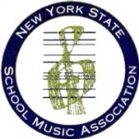 | The NYSSMA Classroom Music Committee is looking for classroom music teachers, PreK thru 12, who are willing to propose an educational session for the Summer and/or Winter Conferences. Please consider sharing one of your favorite lessons or units of study with your colleagues across the state!

Winter Conference Proposals
Session proposals for upcoming Winter Conferences must be submitted online. Please visit the NYSSMA website (www.nyssma.org) for a link to Submittable. The link is usually available between January and mid-March. Please be sure to select “Classroom” if you are submitting a session for us!

Summer Conference Proposals
Session proposals for the upcoming Summer Conference may be submitted online through the following Survey Monkey link.
https://www.surveymonkey.com/r/RC7R55X
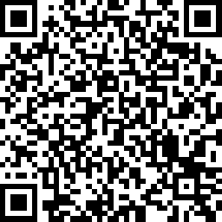

You may also fill out the form on the reverse side of this sheet. If submitting a handwritten form, please email your Summer Conference Proposal to the appropriate chair with the subject header “NYSSMA Summer Conference” by December 15th. You may also include sample handouts and/or a powerpoint for your session if you wish.
Early Childhood | Kim Kane KaneK@canandaiguaschools.org
Elementary | Donna Basile donnabasile3@gmail.com
Secondary School | Anthony Femino profmusic@gmail.com  Jennifer Rafferty jrafferty@cortlandschools.org
Multi-level | Kerry Mero kmero@boquetvalleycsd.org
NYSSMA Summer Conference
Classroom Music Session Proposal
Session Information
Title
Clinician(s):
Description
(max 50 words)
Anticipated equipment requests:
Clinician Contact Information (for person submitting form)
Name
E-mail
Phone
School
Position
Address:

I am aware that in order to be a clinician, I must be a paid member of NAfME/NYSSMA

Signature: ____________________________________________ Date ___________________

