Level 5 Music Pre-Assessment

Student Name: Class:

VOCAL PERFORMANCE
1. Video assessment; input scores below:
a. Vocal Echoes b. Rhythm Echoes c. Song

LISTENING
2. Circle which rhythm you hear:
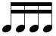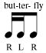

3. Circle the letters which match the form of the melody you hear:

A A¹ A² A A B B¹ A A B C B A A¹ A B

4. Circle the dynamic markings that match the melody you hear:
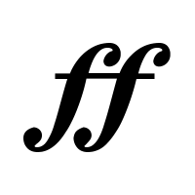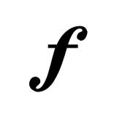

COMPREHENSION
5. How many beats do these notes add up to?

6. Circle the SET of solfège names (syllables) that appear in the melody below.
NOTE: they are not necessarily in the right order. You are looking for the notes that are the INGREDIENTS of the melody.

do do

do, re, mi, sol do, mi, fa, sol, ti mi, sol, la do, re, mi, fa, sol, la, ti

