Level 4 Music Pre-Assessment

Student Name: Class:

VOCAL PERFORMANCE
1. Video assessment; input scores below:
a. Vocal Echoes b. Rhythm Echoes c. Song

LISTENING
2. Circle which rhythm you hear:

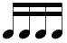

3. Circle the letters which match the form of the melody you hear:

A A B A A B C D A B A B A B B A

4. Circle the dynamic markings that match the melody you hear:
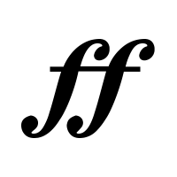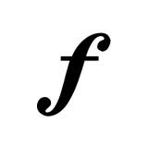

COMPREHENSION
5. Circle the rhythm that contains FOUR beats:

6. Circle the solfège names (syllables) that match the notes in the melody below.

do do

do, re, mi, mi do sol, fa, mi, do, do re, do, do, sol, la mi, re, do, sol, sol

