Level 2 Music Pre-Assessment

Student Name: Class:

PERFORMANCE
1. Video assessment; input scores below:
a. Vocal Echoes b. Rhythm Echoes c. Song

LISTENING
2. Circle which rhythm you hear:

3. Circle which group of 4 notes you hear:

la la la la la
sol sol sol sol sol sol
mi mi mi mi mi

4. Circle the type of song you hear:

AB Call & Response Partnersong Round

COMPREHENSION
5. Circle the trombone:
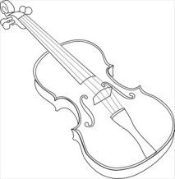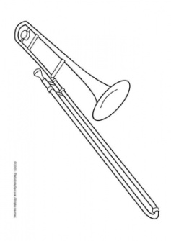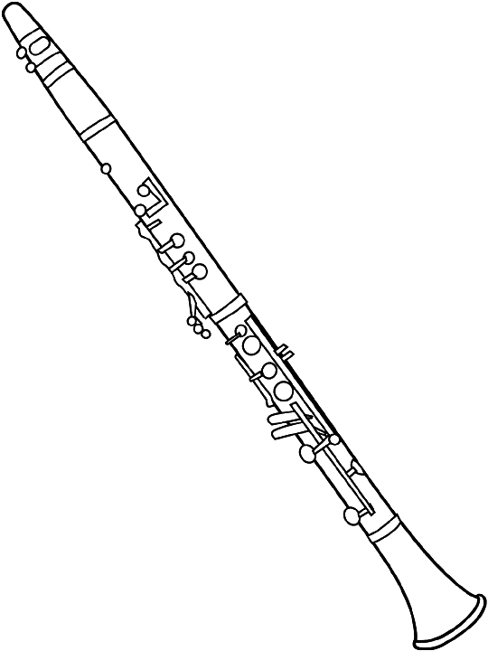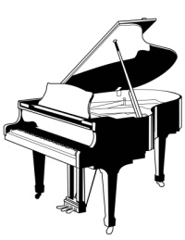

6. Circle the instrument in the string family:
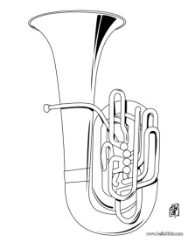

7. Circle the quarter note: 8. Circle the quarter rest:
