Level 1 Music Pre-Assessment – Teacher Evaluation Sheet
Includes directions to be given verbally and the correct answer. Attach this sheet to student response form.

Student Name: Class:

PERFORMANCE
Video assessment; input scores below:
a. Vocal Echoes b. Rhythm Echoes c. Song

LISTENING
1. Circle which rhythm you hear:

2. Circle which notes you hear:

sol sol sol sol sol sol sol sol
mi mi mi mi

COMPREHENSION
3. Circle the guiro below:
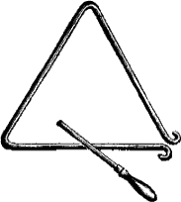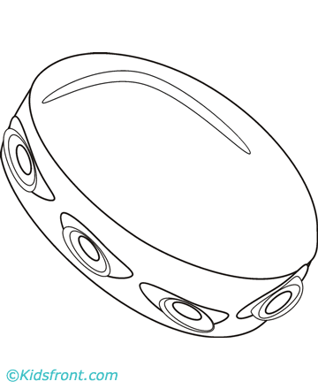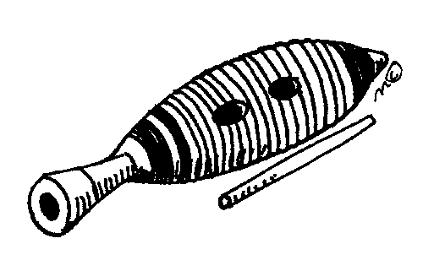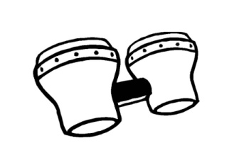

4. Circle the instrument in the metal family:
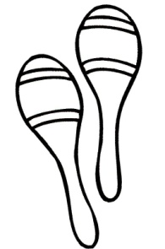

5. Circle the musical symbol that means LOUD:
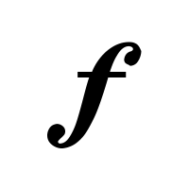

6. Circle the musical symbol that means silence:
